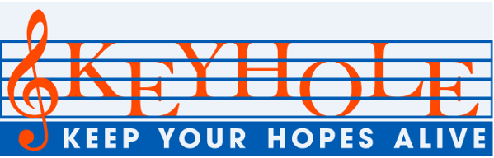

Dear Come Singing friends,
We've survived February! Not the most pleasant one ever, though the snowdrops were lovely, and the daffodils came early... Now perhaps we can look forward to other spring delights and some blue skies.
During the dark gloomy days I was, rummaging around for new songs and Norwich oddities, and the two things came together nicely when I spotted this on a trip to John Lewis!
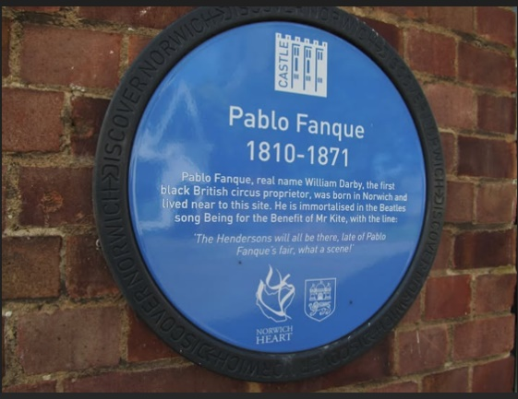
Pablo Fanque was the stage name of William Darby who was born in Ber Street sometime between 1796 and 1810. An accomplished equestrian, he later became Victorian Britain's most famous and first-ever black circus owner. Hiwas also a generous benefactor who put on many benefit performances for other artists or families who had fallen on hard times.
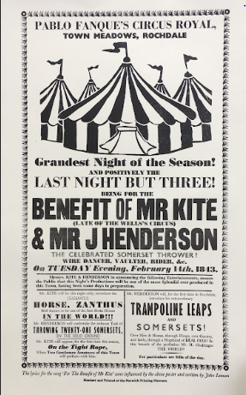
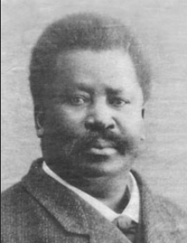
A poster for an 1843 event in Rochdale attracted the attention of Beatle John Lennon and provided the words for the song 'Being for the benefit of Mr. Kite' on the Seargeant Pepper album! So when you look up at the Pablo Fanque student flats opposite John Lewis, think of this gifted Norwich altruist, and his other, musical, memorial!

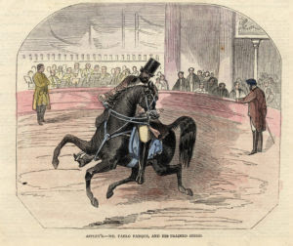

That (somehow!) led on to thinking about other songs which mention trades, work and professions. There are lots of them once you start to look, so here are a few to get the ball rolling...
Jobs and working quiz
- Someone taking his nutrition seriously:' I'm strong to the finich, cause I eats me spinach'...
- A lonely job, keeping power supplies going... 'I drive the main roads, searchin' in the sun for another overload'...
- A sales pitch for someone with a dream: ' It took me years to write, will you take a look? It's based on a novel by a man named Lear and I need a job. I want to be a...'
- Who is this versatile person? He'll darn a sock or fix a clock, an apple cart, a broken heart --He'll mend anything but he'd much rather sing'.
- Beatles again - can you name any of the people working in Penny Lane?
- T'was on the Monday morning, the gas man came to call - but that wasn't the end of it! 'It all makes work for the working man to do' - but which trades?
- One of the less usual job descriptions - but he's OK!! ' I cut down trees. I eat my lunch. I go to the lavatory. On Wednesdays I go shoppin' and have buttered scones for tea.'
- When a Broadway baby says "Good night," It's early in the morning - and who's on his way?
- Who's this? 'He′s always on our street, a fat and jolly red-faced man: he really is a treat!'
- What's his job? ' He looks a proper narner in his great big hobnail boots. He's got such a job to pull 'em up, he calls them daisy roots'.

Answers at the end…
Tree rings
While the February snow was on the ground, the Council arborist team (not lumberjacks!!) came to take down a diseased tree on the verge outside my house. It had been looking peaky,with fungus, and the branches were slumping onto the phone wires but we were all very sorry to see it go. The stump remains, and passers-by often stop to look at the exposed tree rings
The word dendrochronology comes from the Greek 'dendros', (tree) 'chronos', (time) and 'ology' (the study of) and means the science of the annual growth rings laid down by trees. Each ring is the layer produced in one year of the xylem cells which form the wood in the tree, the pale earlywood, and the later darkwood. The newest ring develops just under the bark, and shows the growing conditions in any given year and other irmportant information which can be used to date archaeological sites, reconstruct past climates, and investigate particular environmental events. How wonderful to be able to read the biography of a tree

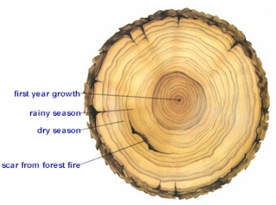
Sunshine….
The flashes of blue skies during the dark months have been so very welcome, and every day brings British Summer Time closer (Sunday 29th March this year.) To keep us all going until then, here are a few familiar sunshine songs to cheer up the last dregs of the dreariness. You'll know them all, but perhaps you might like to complete the titles and think who sang them... Enjoy!

Sunshine songs
- You are my .....
- Here comes the....
- Good day .....
- Island in the ....
- ...... superrman
- You are the .......of my life
- House of the rising ....
- I can see clearly now - it's going to be a bright...... day!
- ..... afternoon
- Bring me ……
Did you make marmalade in January? I didn’t, but there are few smells as wonderful as that of freshly boiled oranges and sugar – so wide-awake and appetising! It’s probably too late to buy Seville orangs now, but how about a delicious marmalade cake? This recipe originally came from Country Living magazine and was highly recommended by a neighbour.
Beat together 8 oz butter and 8 oz sugar
Add 3 beaten eggs,
3 oz yogurt,
2 oz milk,
3 oz ground almonds,
5 oz self-raising flour
a teaspoon of baking powder
2 tablespoons marmalade.

My friend didn’t stipulate the baking time, but perhaps try Gas Mk 4-5 for 30 minutes and then have a look? Good luck!!

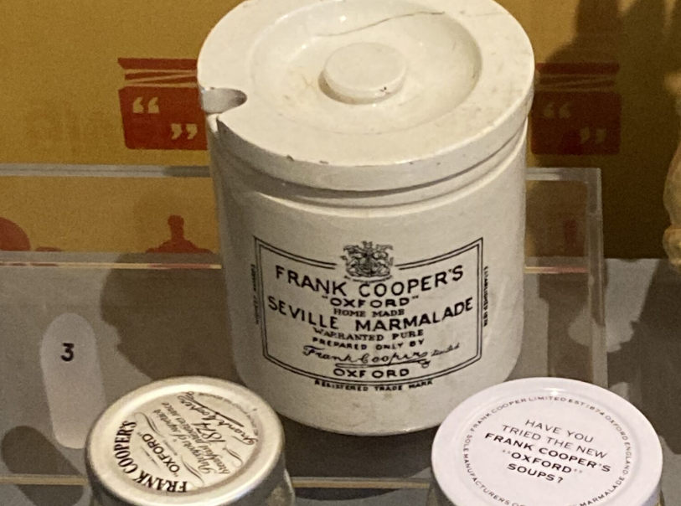

We hope that March will be a good month for you, with the scent of hyacinths, the feel of sunshine on your back and songs in your heart! Perhaps we'll see you at singing: on Tuesdays March 10th and 24th athe Millennium Library and Friday March 20th at Earlham Library...
Keep well and cheery!

With best wishes and love from all at Come Singing

Jobs and work quiz answers

- Popeye https://www.youtube.com/watch?v=i8O0PwGSoO0
- Wichita linesman https://www.youtube.com/watch?v=Q8P_xTBpAcY
- Paperback writer https://www.youtube.com/watch?v=yYvkICbTZI
- Umbrella man https://www.youtube.com/watch?v=wcHxS7cLEjc
- Barber, banker, fireman nurse https://www.youtube.com/watch?v=z7syIxQCquo
- Carpenter, electrician, glazier https://www.youtube.com/watch?v=8VKNF5mEXA4
- The Lumberjack song https://www.youtube.com/watch?v=FshU58nI0Ts
- The milkman https://www.youtube.com/watch?v=AmY1kXeIeaw
- The laughing policeman https://www.youtube.com/watch?v=hI1nPd7hezM
- My old man's a dustman https://www.youtube.com/watch?v=ODEShfdxoR0

Sunshine songs
- You are my sunshine - Jimmie Davis https://www.youtube.com/watch?v=i9M5LoDIWPE
- Here comes the sun - The Beatles https://www.youtube.com/watch?v=KQetemT1sWc
- Good day sunshine - The Beatles again https://www.youtube.com/watch?v=6e01nNA02vw
- Island in the sun - Harry Belafonte https://www.youtube.com/watch?v=PnAV62l_Fyk
- Sunshine superrman - Donovan https://www.youtube.com/watch?v=hTuPbJLqFKI
- You are the sunshine of my life - Stevie Wonder https://www.youtube.com/watch?v=SbenaOqv4yQ
- House of the rising sun - The Animals https://www.youtube.com/watch?v=4-43lLKaqBQ
- I can see clearly now - it's going to be a bright sunshiny day! - Johnny Nash https://www.youtube.com/watch?v=b0cAWgTPiwM
- Seasons in the sun - Terry Jacks https://www.youtube.com/watch?v=21I_XsR400Q
- Sunny afternoon - The Kinks https://www.youtube.com/watch?v=zhjW5bcqIQw
- Bring me sunshine- Morecambe and Wise https://www.youtube.com/watch?v=GNbTJ2AnDKc

